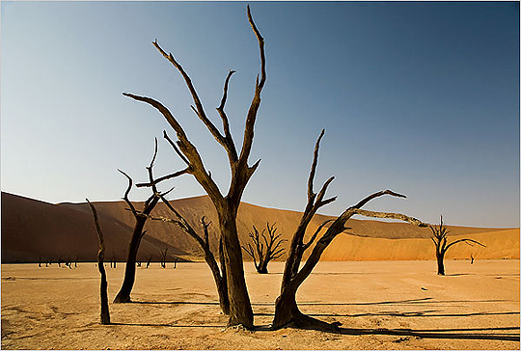
PET- CT AND RADIONUCLIDE THERAPY:
A TEACHING COURSE

Windhoek, Central Hospital
Windhoek, Namibia, 9-10/10/2012


Organizing Committee:
Alberto Signore, Alex Maes, Felix Mottaghy, Mike Sathekge, Rudi Dierckx, Christophe Van de Wiele
Local Host:
Choky Herman

PRELIMINARY PROGRAMME

Tuesday 9th of October 2012

FDG PET/CT for non-oncological applications

8h00-8h30 Official opening + current status NUCMED in Namibia Herman, Windhoek, Namibia
8h30-9h00 Nuclear Medicine (focus PET/CT) in S-Africa, current status Sathekge, Johannesburg, S-A
9h00-9h30 FDG PET-CT imaging: the basics, Maes, Leuven, Belgium
9h30-10h00 FDG PET-CT, normal findings, Dierckx, Groningen, Netherlands

10h00-10h30 Coffee-break

10h30-11h00 FDG PET-CT imaging in spondylodiscitis Van de Wiele, Ghent, Belgium
11h00-11h30 FDG PET-CT imaging in PJI and diabetic foot Signore, Roma, Italy
11h30-12h00 FDG PET-CT imaging in IBD/sarcoidosis/RA Signore, Roma, Italy

12h00-14h00 LUNCH-break

14h00-14h30 FDG PET-CT imaging in FUO Van de Wiele, Ghent, Belgium
14h30-15h00 FDG PET-CT imaging in HIV/TB Sathekge, Johannesburg, S-A
15h00-15h30 FDG PET-CT imaging in vasculitis Van de Wiele, Ghent, Belgium
15h30-16h00 FDG PET-CT imaging in vascular graft infection Van de Wiele, Ghent, Belgium

16h00-16h30 Coffee-break

16h30-17h00 FDG PET-CT imaging of the heart Gheysens, Leuven, Belgium
17h00-17h30 FDG PET-CT imaging in dementia Dierckx, Groningen, Netherlands
17h30-18h00 Clinical cases Staff Pretoria

Wednesday 10 october 2012

FDG PET/CT for oncological applications and radionuclide therapy

8h10-8h30 FDG-PET CT imaging in SCCHN Dierckx, Groningen,Netherlands
8h30-9h00 FDG-PET CT imaging in lung carcinoma Maes, Leuven, Belgium
9h00-9h30 FDG PET-CT imaging in SPN in Africa Sathekge, Johannesburg, S-A
9h30-10h00 FDG PET-CT imaging in Oesophag. carcinoma Mottaghy, Aachen, Germany

10h00-10h30 Coffee-break

10h30-11h00 FDG PET-CT imaging in pancreatic carcinoma Mottaghy, Aachen, Germany
11h00-11h30 FDG PET-CT imaging in brain tumors Dierckx, Groningen, Netherlands
11h30-12h00 FDG PET-CT imaging in melanoma Maes, Leuven, Belgium

12h00-14h00 LUNCH-break

14h00-14h30 FDG PET-CT imaging in gynaecological tumors Mottaghy, Aachen, Germany
14h30-15h00 FDG PET-CT imaging in lymphoma Andre, Brussels, Belgium
15h00-15h30 FDG PET-CT imaging in colorectal carcinoma Mottaghy, Aachen, Germany
15h30-16h00 FDG PET-CT imaging in thyroid carcinoma Signore, Roma, Italy

16h00-16h30 Coffee-break

16h30-17h00 RNT of thyroid diseases Signore, Roma, Italy
17h00-17h30 SIRT Van de Wiele, Ghent, Belgium
17h30-18h00 Clinical cases Staff Pretoria

OFFICIAL SPONSORS



